**TENTATIVE THEORETICAL STRUCTURE AND INFRARED SPECTRA OF METHYL ISOCYANATE ICE**

*V. Timón1, G. Molpeceres1, V.J. Herrero1, R. Escribano1, B. Maté1, I Tanarro1 and M. A. Moreno1*

*1Instituto de Estructura de la Materia, IEM-CSIC, Serrano 123, 28006 Madrid, Spain.*

**Introduction:** The prebiotic molecule methyl isocyanate (CH3NCO) was recently detected at the surface of comet 67P/CG [1] and shortly afterwars in the gas-phase of the interstellar medium [2,3]. Its estimated abundance with respect to water was found to be very high (1.3%) in the comet.

As far as we know the crystal structure of CH3NCO is unknown. Density functional theory (DFT), which is generally accepted as a good compromise between accuracy and computing cost for solid state materials, may be a good tool for the structural modelling of CH3NCO.

We first carried out DFT calculations on the known structure of isocyanic acid. We optimized the geometrical structure and predicted the infrared spectra, using the CASTEP code [4], achieving a satisfactory comparison. Next, we produced a tentative structure for methyl isocyanate by substituting the acid hydrogen atoms by methyl groups.

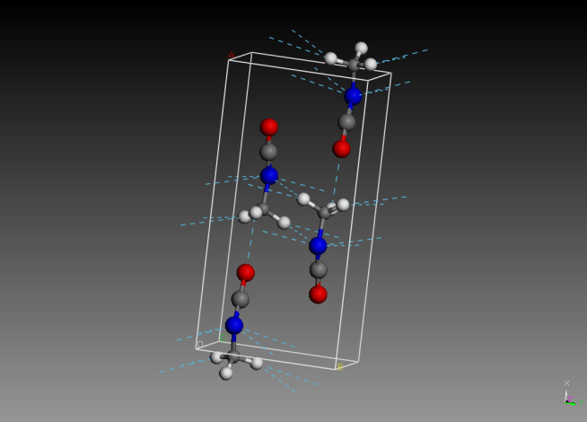

**Figure 1:** Calculated methyl isocyanate monoclinic P21/m structure showing intramolecular hydrogen bonding (dashed blue lines).

Several symmetry groups and structures were proven by comparing their infrared spectra with an experimental spectrum of a polycrystalline sample measured in our laboratory at 20 K. Based on the agreement of the IR spectra, the most likely structure is that of a monoclinic crystal with P21/m symmetry, spatial group 11. We show in Figure 2 the comparison between the calculated and experimental infrared spectra, with a reasonable agreement with some differences in the most intense band.



**Figure 2:** Calculated and measure Infrared spectra.

The degree of accordance achieved suggests that the structure of crystalline methyl isocyanate should not be very far from the theoretical one, which corresponds to a monoclinic crystal with a unit cell with four molecules forming a network of intramolecular hydrogen bonds in a similar way as the isocyanic acid.

**References:**

[1] Goesman, F., Rosenbauer, H., Brederhöft, J. H. et al. Science, 349, aab0689, 2015

[2] Halfen D. T., Ilyishin, V. V. and Ziurys L. M. ApJ, 812, L5, 2015

[3] Cernicharo, J., Kisiel, Z., Tercero, B.; et al. A&A, 587, L4, 2016**.**

[4] S. J., Clark, M. D. Segall, C. J. Pickard, et al. Z. Kristall., 220, 567-570, 2005.